
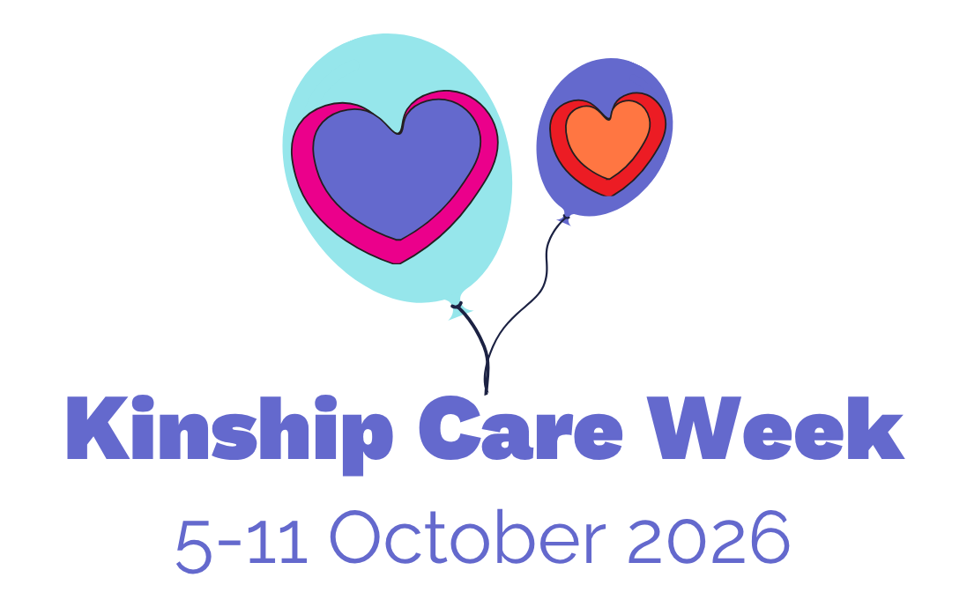
Invite your local Councillor to a support group meeting
Inviting a Local Councillor to a support group meeting can be a really effective way to share your experiences with local decision makers and help to raise the profile of kinship care in your community. Kinship Care Week is a great time to do this to provide a way for Councillors to mark the Week and celebrate kinship carers in their area.

How to contact your Councillor
You can find out who your local councillors are by going to your local authority website and looking in the menu for “Your Councillors” or similar. This is not the same on every website and could be under headings like “Council and Elections”, “Elected Representatives”, “Your Council” or similar.
Once you’ve found your list of Councillors, choose any that you would like to attend your meeting – this could be based on the Ward they represent (e.g. if you live in that Ward or if it’s where your group meets) or if you have any personal connection to them – and their email addresses should be available on the website.
Local authorities who deliver children's services will also have a specific named Councillor who oversees the council's work to help children and families. Their role title might vary but is normally something like 'Lead Member for Children's Services' and they'll likely be a member of the council's Cabinet. Given their role, they're a good person to invite to a meeting so they can learn more about kinship care.
If you would like any support contacting your Councillor, or help with what to say when you meet them, please contact Kelly on kelly.taylor@kinship.org.uk.

Template email to your Councillor
You can copy and paste the below template email, and edit it to make it more personal or to share a bit about your group if you would like to – it’s best if the email clearly comes from you!

Email subject:
Invitation to Kinship Care Week event on [date] October at [place]

Email copy
Dear Councillor [name],

I am writing to invite you to a Kinship Care Week 2026 event on [date] at [place], organised by [name of local group] Group.
We are a group of kinship carers who have stepped in to raise a family or friends’ child where they cannot live with their birth parents. We meet regularly having developed a much-needed supportive network for kinship carers in our community.
Kinship Care Week takes place from 5 to 11 October 2026. It is an annual celebration for kinship carers and an important opportunity to recognise the contribution we make to society raising more than 141,000 children across England and Wales in stable and loving homes. Kinship carers often come together to mark the week and to raise awareness and build understanding of kinship care and our kinship families.
There are more than double the number of children in kinship care than in foster care. However, unlike foster and adoptive families, many of these families receive little to no support. Your attendance at our Kinship Care Week event would mean a lot to the kinship carers and their families that live in your area. If you are interested in finding out more about kinship care, please visit www.kinship.org.uk.
This event will give you an opportunity to speak directly with kinship carers about their experiences and the challenges they are facing locally, and get their views on how local authorities such as [local authority] can deliver improved support for all kinship families.
The event will be fairly informal, and celebratory, giving you a chance to sit down and have a chat and a cup of tea with kinship carers. Please contact [your contact details] to RSVP and for further information. We look forward to your reply.
Yours sincerely
[Your name]
On behalf of [group name]

