**Kinship Friendly Employer Scheme: Gold, Silver and Bronze Standard checklists**

***Purpose: These checklists allow an organisation to cross-reference existing and new policies to ascertain what standard they will be recognised at as a Kinship Friendly Employer, with three tiers of Gold, Silver and Bronze.***

***Meeting these standards and being recognised as a kinship friendly employer will demonstrate to your workforce, suppliers, stakeholders and prospective employees that you value, understand and support kinship carers and have received recognition from the leading kinship care charity for meeting a high threshold of support.***

***Acknowledging that lack of statutory underpinning for kinship carers in the workplace, Kinship welcomes all employers making an effort to recognise, value and support kinship carers in their workforce. Over time, an employer could move up through the tiers, perhaps they develop new policies or are able to make business cases for increasing the provisions available for kinship carers.***

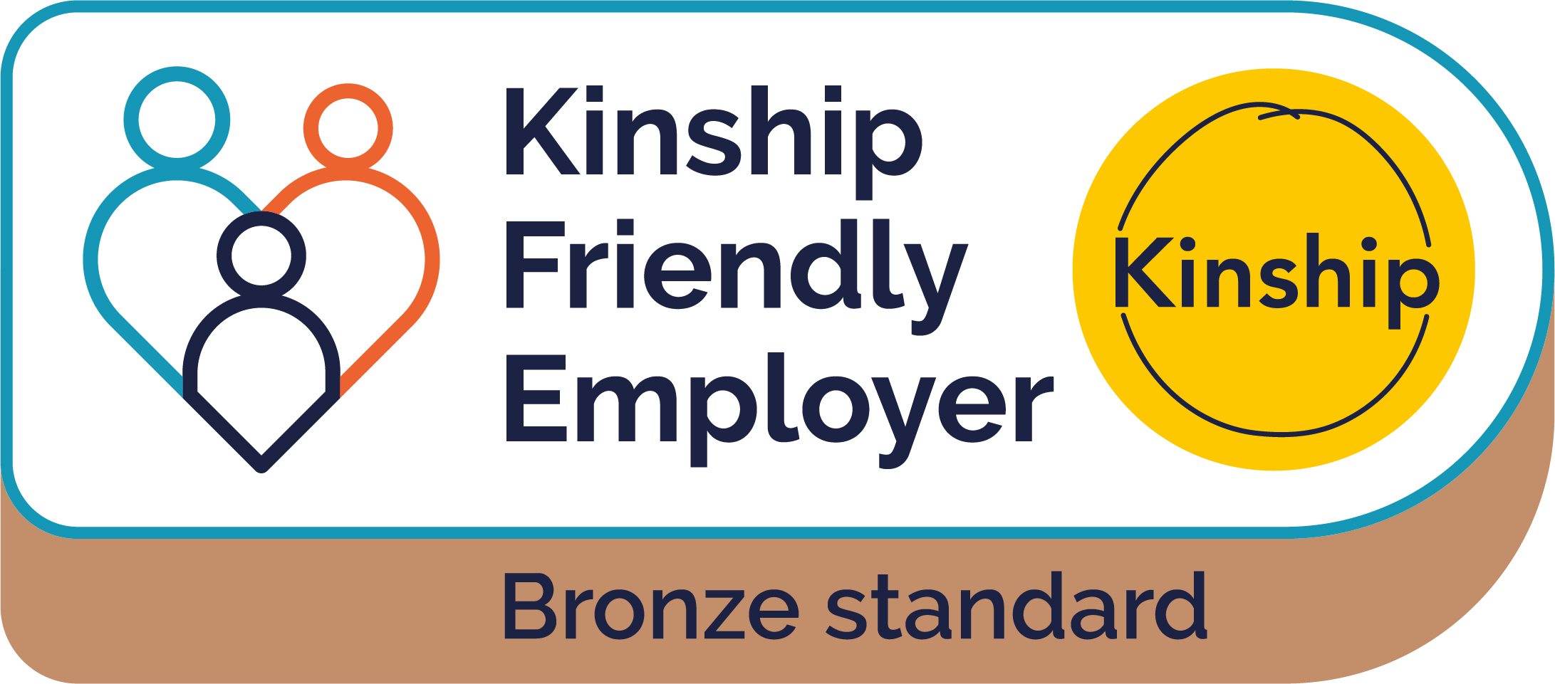

* Company does not provide paid kinship care leave, but includes kinship carers in all other family friendly policies, e.g. paid/unpaid Dependents Leave; Flexible Working; subsidies for childcare and/or healthcare plans which can include dependents.
* Provide signposting and information for kinship carers in the workforce (template available in Kinship Friendly Employers toolkit) via staff intranet, internal communications or similar and promote annual Kinship Care Week to staff members (downloadable resource packs available at [www.kinship.org.uk](http://www.kinship.org.uk) ).
* Support managers and leaders to be kinship-aware and as flexible as business needs can accommodate when supporting kinship carer staff members (guidance available in the Kinship Friendly Employers toolkit).

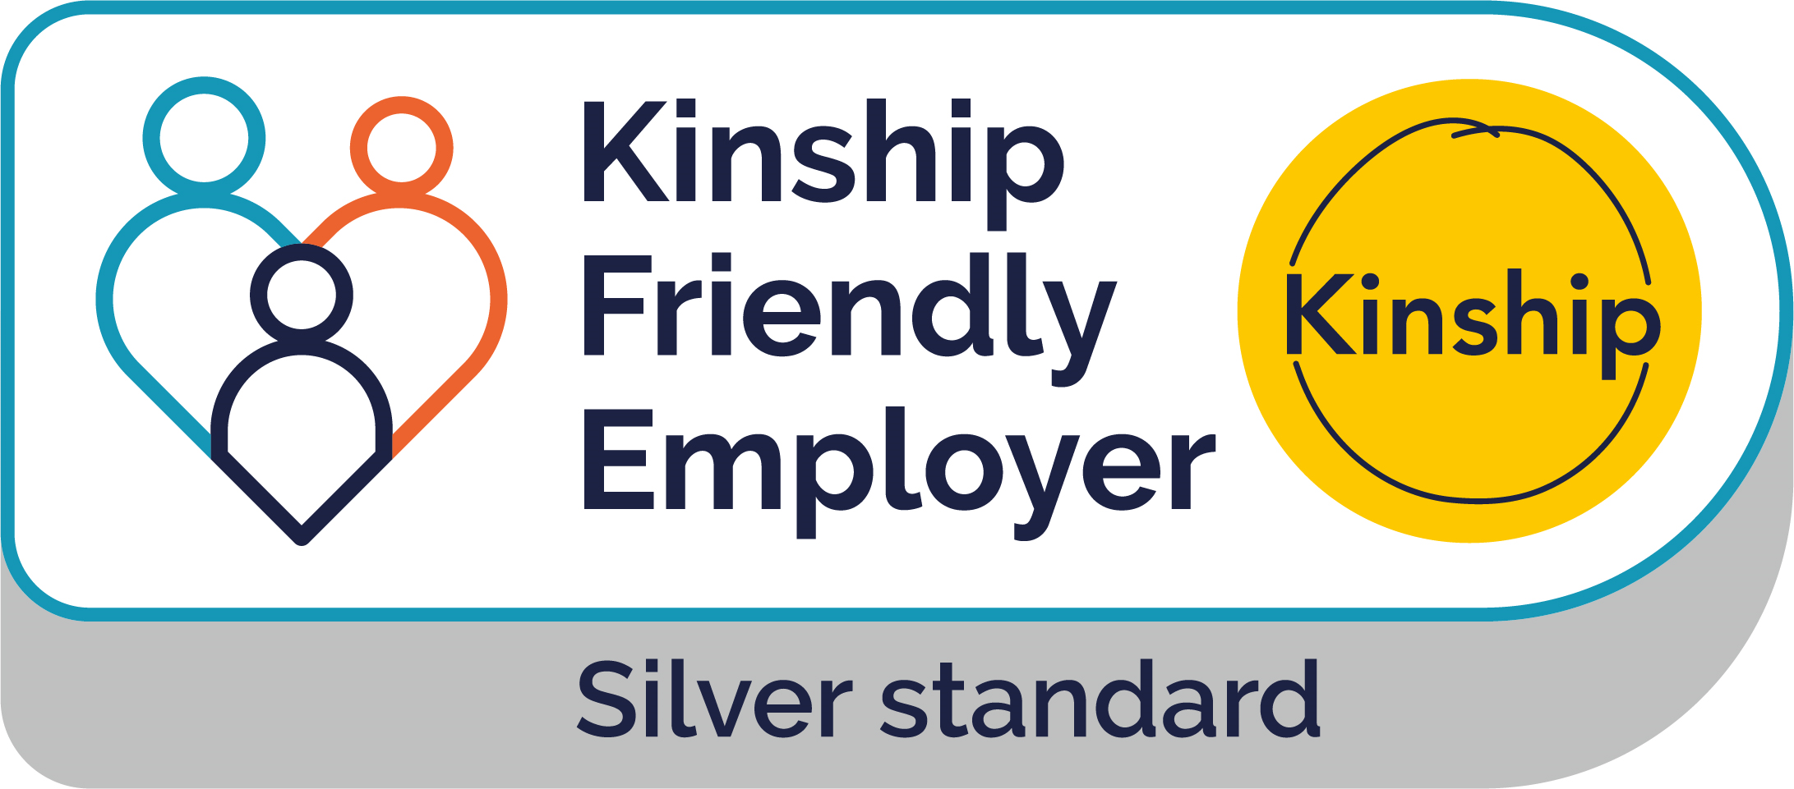

* Provision of paid kinship care leave, which allows kinship carers to take paid time off work and return to their job, but where an organisation is unable to offer the equivalent leave as they do for adoption leave.
* Recognition, support and inclusion for kinship carers in the workforce as detailed in Bronze standard checklist.

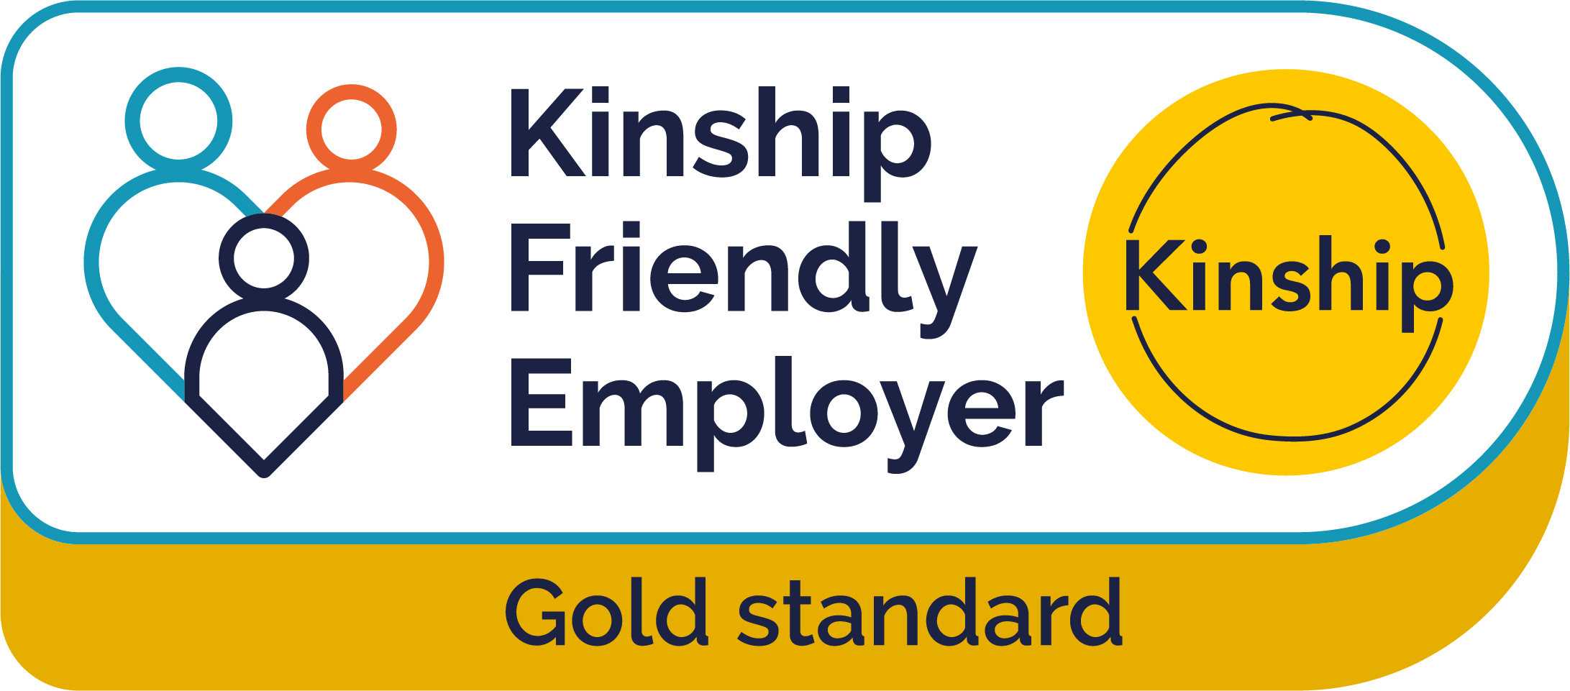

* Provision of paid kinship care leave on a par with the organisation’s provision of adoption leave. For example, for organisations who offer statutory adoption leave, kinship care leave should be offered at the equivalent level, likewise organisations who provide an enhanced adoption leave offer should provide the same offer for kinship carers.
* Recognition, support and inclusion for kinship carers in the workforce as detailed in Bronze standard checklist.